# ETS Decomposition

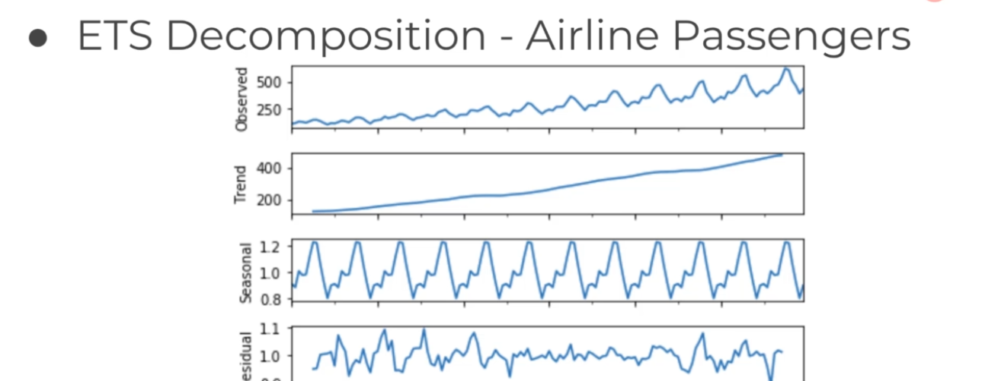

ETS Decomposition would separate the Trend, Seasonality and the Residual term which cannot be explained by the Trend and Seasonality.

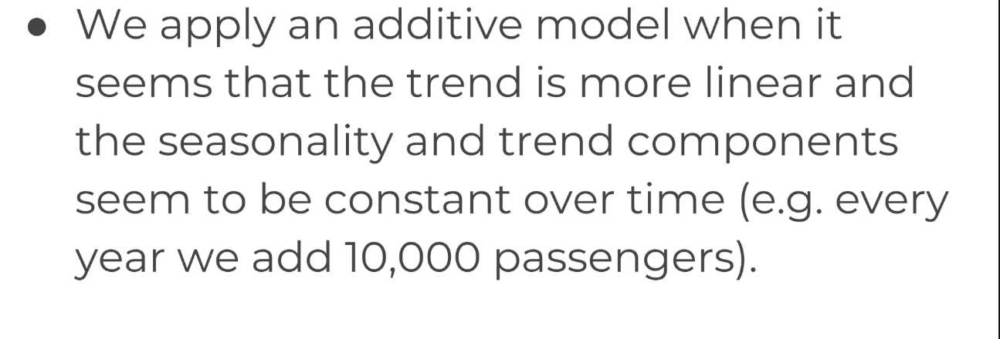

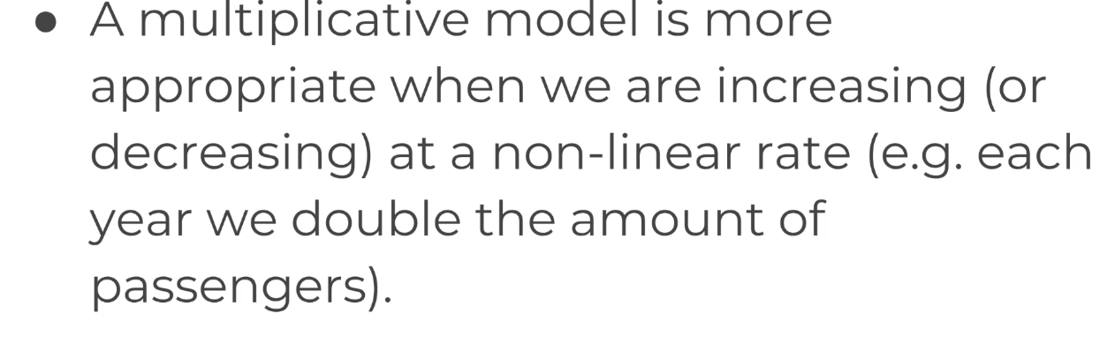

# Simple Moving Average

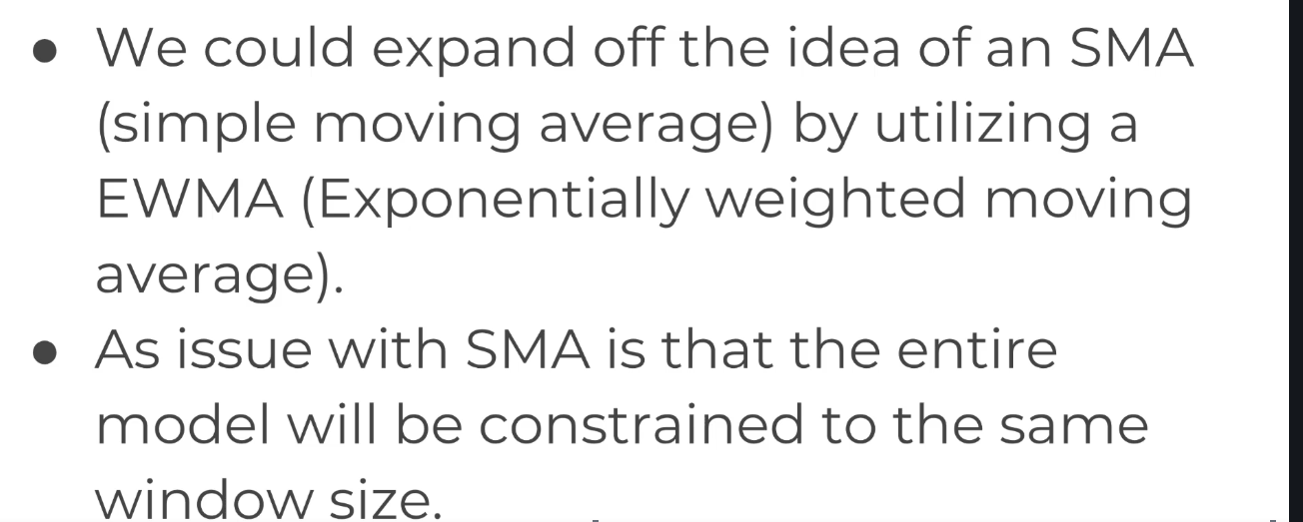

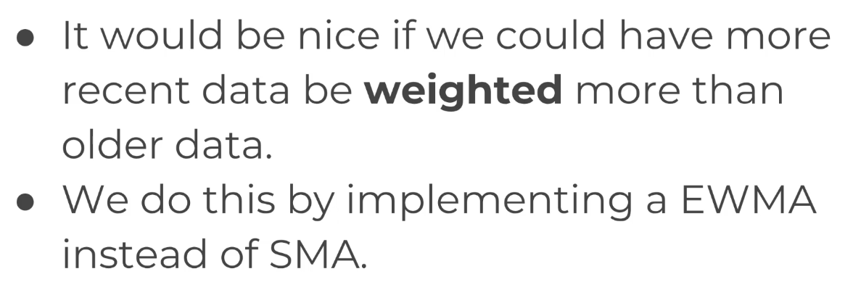

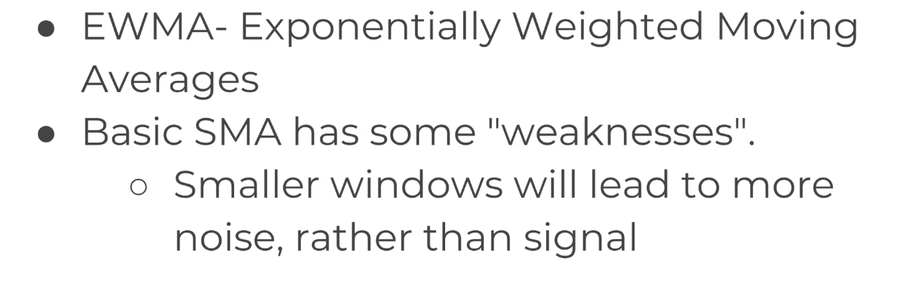

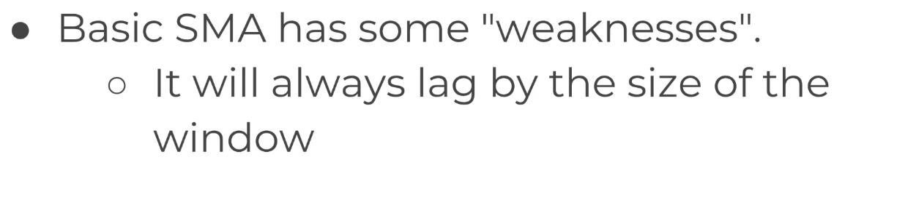

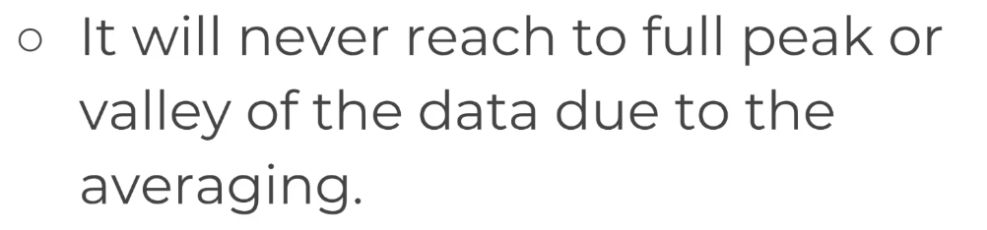

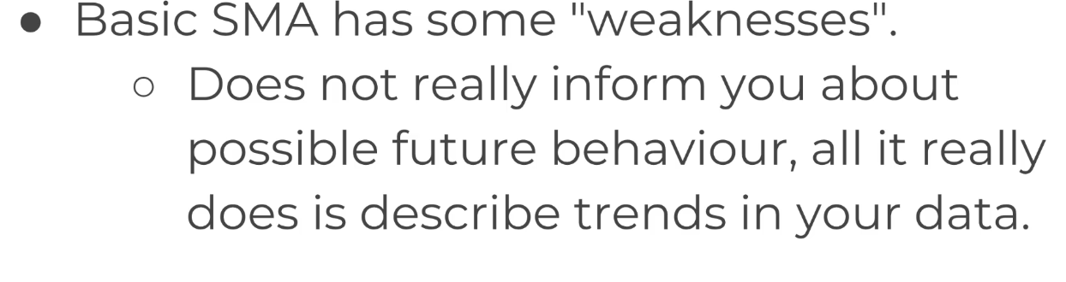

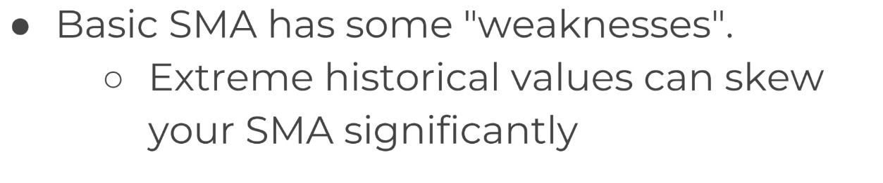

If we are trying to model economic data and there was a recession, then that dip would be reflected in the entirety that the window passes over that recession which may not be accurate.

# 

# **EWMA Explanation**

To help fix these errors, we use the EWMA or the Exponentially Weighted Moving Average method. EWMA would allow us to reduce the lag effect from the SMA and it will put more weights on the values that occurred more recently ( by applying more weights to the more recent values).

The amount of weight applied on the most recent values will depend upon the actual parameters used in the EWMA and number of periods given in the window size.

# **Holt-Winter Method**

Holt’s Winter model has the forecast equation, along with three smoothing parameters which account for the level, trend and seasonality of the data.

The Holt Winter equation has two variations which differ in the nature of the seasonal component. Similar to ETS, there is an additive and a multiplicative method.

The **additive method** is preferred when the seasonal variation is roughly constant throughout the series while the **multiplicative method** is used when the seasonal variations are changing proportional to the level of the series.

So, Additive is used when the time series shows a straight line movement and multiplicative is used when the time series shows a curved movement.

Using Neural Network

**ReLU** - Rectified Linear Unit.

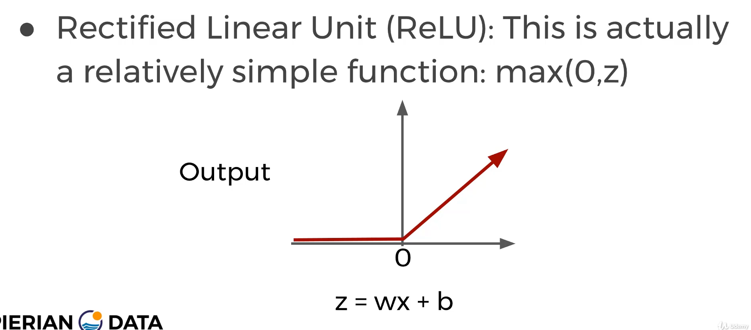

For a given function z=wx+b give the maximum of values of (0,z).

**KERAS**